Nutrition Notes

Calories are a measure of the energy found in food and used by the body
- 1 gram of carbohydrates = _______ calories
  - Can be found in (which foods):

- 1 gram of protein = _______ calories
  - Can be found in (which foods):

- 1 gram of fat = _______ calories
  - Can be found in (which foods):

A person’s daily caloric needs varies depending upon:
a._______________________
b._______________________
c._______________________

metabolism is a process that occurs __________________________
and generates the calories our bodies need on a ___________ _________.
It is a series of __________________ ________________ in which food is broken down an ______________ is ________________ .
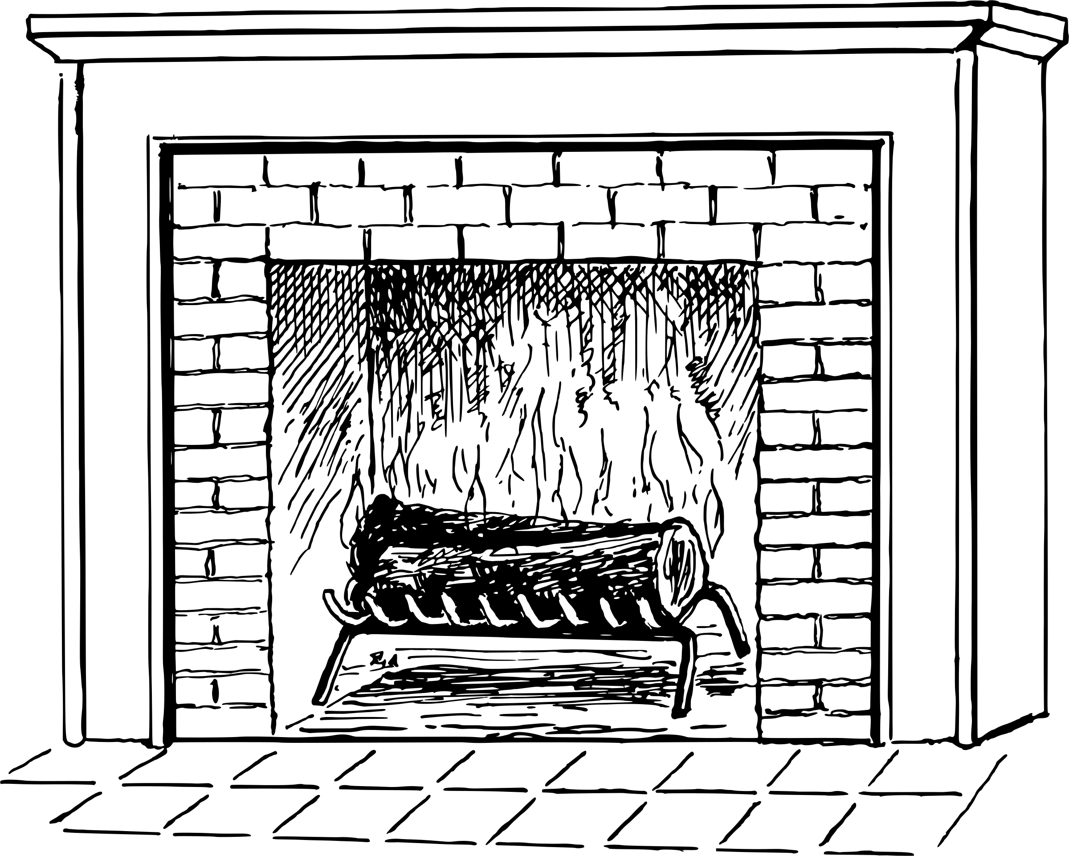Metabolism is like a fireplace burning wood to produce heat
When a person consumes more calories than they use, the extra calories are stored as ___________
Basal Metabolic Rate : ____________________________
_____________________________________________________
- Responsible for up to ______% of calories used by the body
Basal metabolic rate is like a car at a red light

According to the video, 1/3 of U.S. adults are considered ______________
- This can be attributed to the U.S. diet being high in
________________ & _________________
Nutrition Labels
If you want to know how much of a food is in a package, what two headings should you look for?
- _______________________________________
- _______________________________________
Everything listed on the nutrition label is for ________ serving(s)
What type of fat is “bad” fat that is linked to heart disease? ___________
Only the nutrients deemed ___________ _________________ make it to the nutrition label.
- Ingredients are found at the bottom of most labels. Ingredients are things you can find in your pantry or fridge (eggs, flour, salt, etc.) The ingredient that is listed first, is the one that your product contains the most of.
Now let’s practice: Go to Wizer.me and complete the activity the code is 5NCH5S

